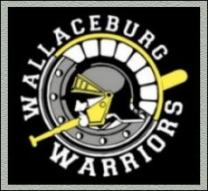
WALLACEBURG MINOR BASEBALL COACHING EVALUATION
TEAM: ________________________________ Boys/ Girls
HEAD COACH or ASSISTANT COACH NAME _____________________________________
Positive Highlights of the Season:

Areas of Concern about Season: ___________________________________________________________________________________ ___________________________________________________________________________________ ___________________________________________________________________________________ ___________________________________________________________________________________ ___________________________________________________________________________________
Suggestions for Improvement or Opportunity for Praise:
****************************************************************************** Thank you for taking the time to submit feedback on your season. Information will be kept confidential and be used to assist making future decisions regarding baseball coaching selections. Please submit in confidence to wallaceburgminorbaseballassociation@outlook.com

